**What are window functions?**

**Window functions** perform calculations on a set of rows that are related together. But, unlike the aggregate functions, windowing functions do not collapse the result of the rows into a single value. Instead, all the rows maintain their original identity and the calculated result is returned for every row.

## **1. Sum**

One of the most common use cases for the SUM window function is calculating a running sum. Let’s look at an example:

SELECT o.occurred_at,  
 SUM(o.gloss_qty) OVER(ORDER BY o.occurred_at) as running_gloss_orders  
 FROM demo.orders o

To break down the syntax here, SUM(o.gloss_qty) defines the aggregation—we’re going to be taking a sum of gloss_qty. Next, the OVER(ORDER BY o.occurred_at) clause tells your SQL engine to go row-by-row and take the sum of every record of gloss_qty in order by occurred_at up until the row it’s currently looking at.

We can also create separate running sums for different groups within our dataset by adding a PARTITION BY as seen below:

SELECT o.occurred_at,  
 o.account_id,  
 SUM(o.gloss_qty) OVER(PARTITION BY o.account_id   
 ORDER BY o.occurred_at) as running_gloss_orders  
 FROM demo.orders o

## **2. Row Number**

Ah, row number. This is my favorite window function. I commonly use ROW_NUMBER when I want to return the most recent record of a table I’m working with. ROW_NUMBER simply returns the number of the given row starting with 1, which is the first record as defined by the ORDER BY. No need to specify a variable in the parenthesis here!

WITH  
 order_ranks as (  
 SELECT o.id,  
 o.account_id,  
 o.gloss_qty,  
 o.gloss_amt_usd,  
 ROW_NUMBER() OVER(PARTITION BY o.account_id   
 ORDER BY o.occurred_at DESC) as acct_order_rank  
 FROM demo.orders o  
)  
  
 SELECT *  
 FROM order_ranks  
 WHERE acct_order_rank = 1

Note the DESC in the ORDER BY —this tells the SQL engine to order rows by occurred_at in descending order (i.e. latest record first.) The query above returns the most recent record in the orders table for each account. This query also makes use of CTEs (if those are a foreign concept, read [our latest post on them](https://mode.com/blog/use-common-table-expressions-to-keep-your-sql-clean/)).

## **3. Dense Rank**

DENSE_RANK works similar to ROW_NUMBER but differs in how it handles cases where two rows for the field specified in your ORDER BY have identical values. DENSE_RANK will assign rows with identical ORDER_BY values the same number, whereas ROW_NUMBER will produce distinct values.

SELECT o.id,  
 o.account_id,  
 DATE_TRUNC('day',o.occurred_at) as occurred_day,  
 o.gloss_qty,  
 o.gloss_amt_usd,  
 DENSE_RANK() OVER(PARTITION BY o.account_id   
 ORDER BY DATE_TRUNC('day',o.occurred_at)) as dense_rank  
 FROM demo.orders o

You can see in the results below that the 2nd and 3rd rows have the same dense_rank value of 2. Oh, and you’ll notice that the window function above uses a value derived from another SQL function DATE_TRUNC —nesting SQL functions inside a window function is fair game.

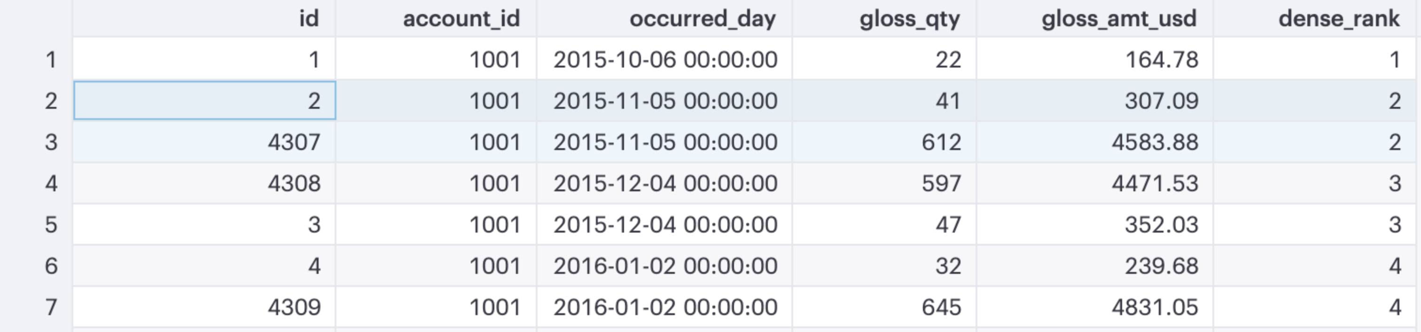

## **4. Lag**

The LAG function is a favorite among time series junkies. This function allows you to compare a row to any of the rows preceding it. So for instance, if you wanted to find out how one order of gloss_qty compared to the previous orders, this is the function to use.

SELECT o.id,  
 o.occurred_at,  
 o.gloss_qty,  
 LAG(gloss_qty,1) OVER(ORDER BY o.occurred_at) as order_lag_1,  
 LAG(gloss_qty,2) OVER(ORDER BY o.occurred_at) as order_lag_2,  
 LAG(gloss_qty,3) OVER(ORDER BY o.occurred_at) as order_lag_3  
 FROM demo.orders o

Keep in mind that the first n rows of your data will be NULL (where n is the number of “lags” you specify). You can see this in the results of our query:

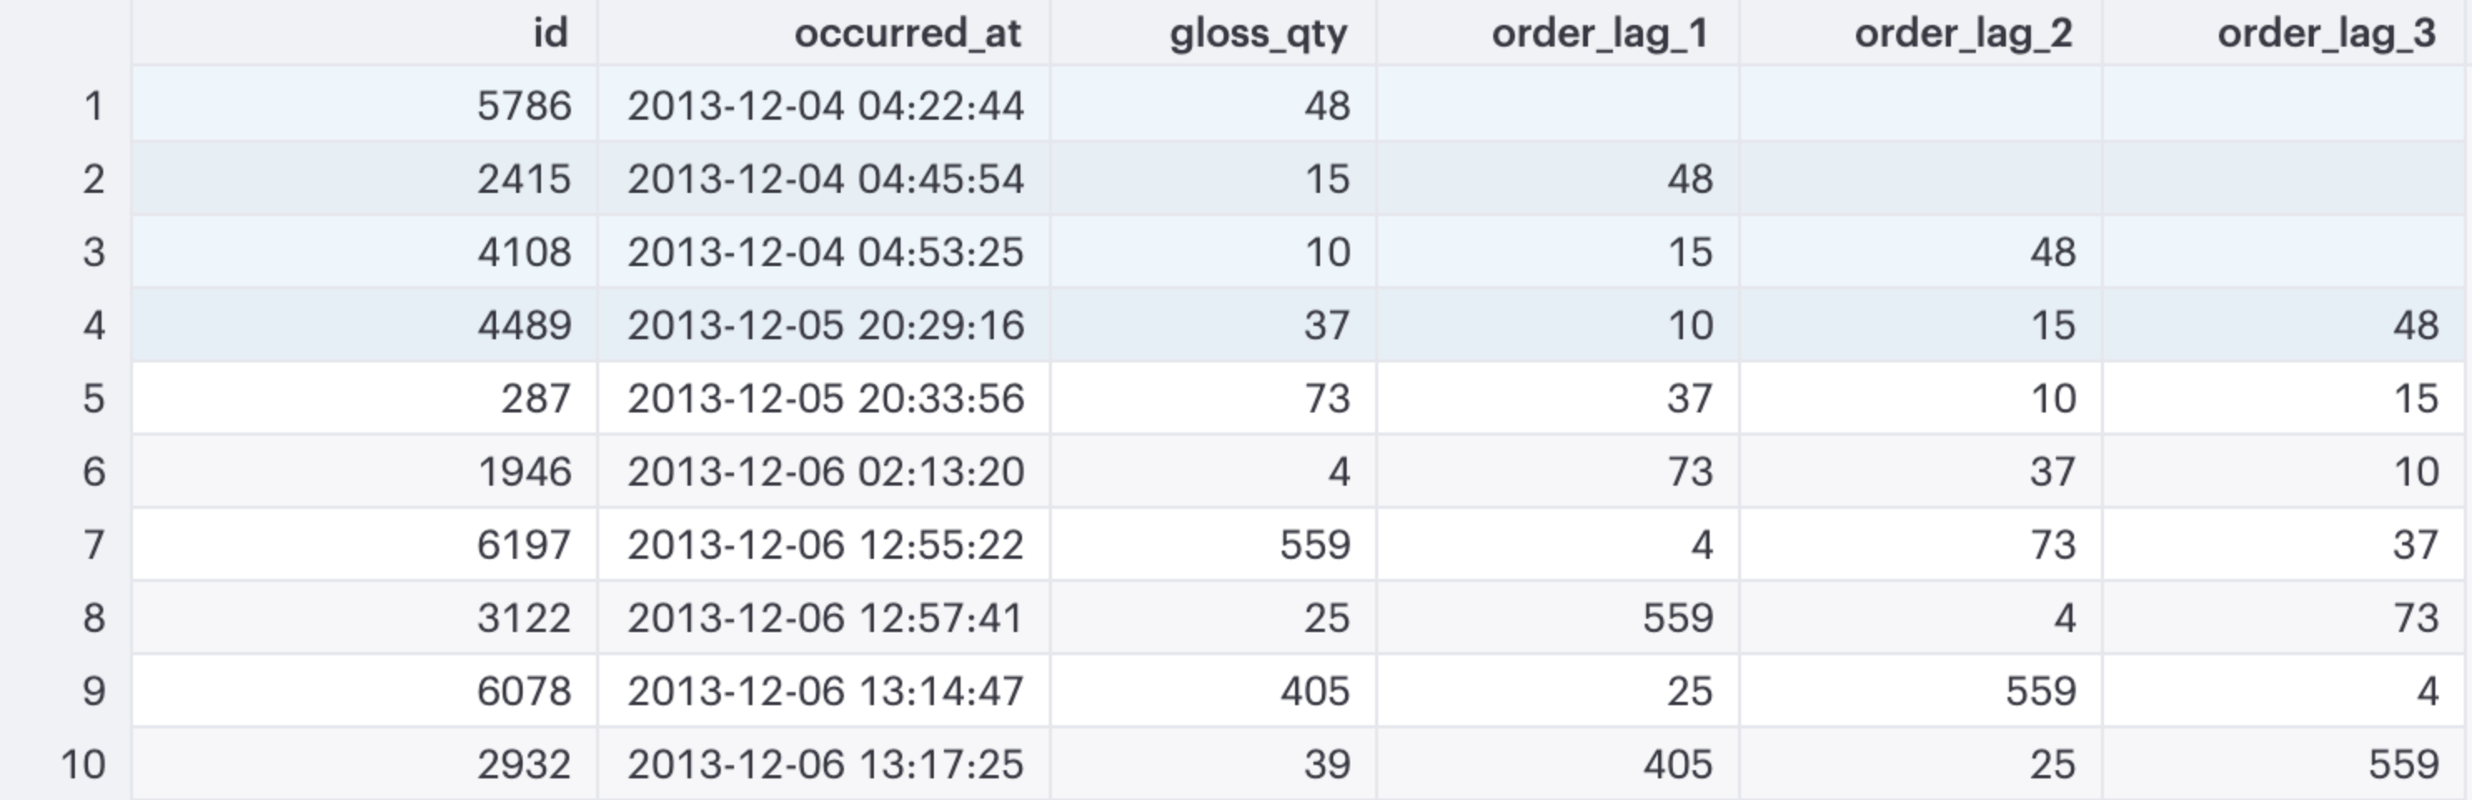

## **5. Max**

And finally, we can top off this list with MAX. MAX works in the same way as SUM so I’m going to spice up the example with some more advanced syntax. Let’s say that I want to see how a current order stacks up against the highest order quantity among the previous 5 orders for gloss_qty. We can do this by adding in some additional syntax in our ORDER BY clause.

SELECT o.id,  
 o.occurred_at,  
 o.gloss_qty,  
 MAX(gloss_qty) OVER(ORDER BY o.occurred_at   
 ROWS BETWEEN 5 PRECEDING AND 1 PRECEDING) as max_order  
FROM demo.orders o

After we specify the field to order by, we add a definition for our window size: ROWS BETWEEN 5 PRECEDING AND 1 PRECEDING. This clause is essentially saying, "look back across the previous 5 orders (not including the current order) and take the maximum value."

This syntax is flexible and can define any window across your dataset. The syntax typically looks like:

ORDER BY [order_var] ROWS BETWEEN window start AND  
 window_end

where **window_star**t and **windown_end** take on one of the following values:

* UNBOUNDED PRECEDING (i.e. all rows before the current row)
* [VALUE] PRECEDING (where [VALUE] = # of rows behind the current row to consider)
* CURRENT ROW
* [VALUE] FOLLOWING (where [VALUE] = # of rows ahead of the current row to consider)
* UNBOUNDED FOLLOWING (i.e. all rows after the current row)

Window functions are incredibly powerful tools that enable quick and flexible analysis, all in the context of the SQL editor. Now, go find your favorite window function and analyze away!